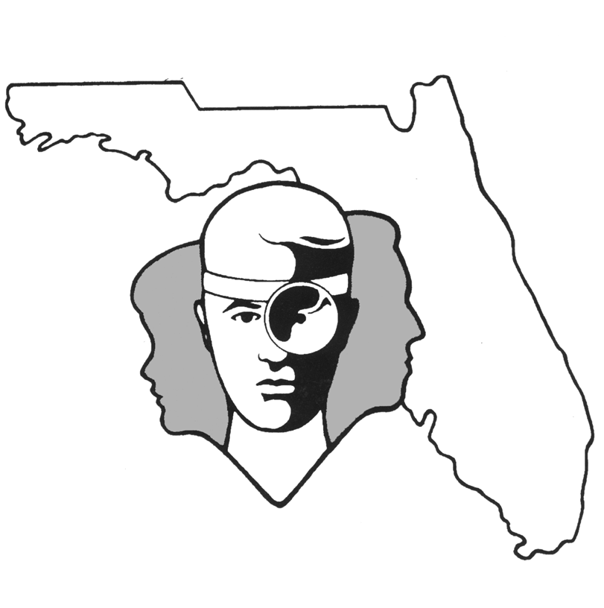

TALLAHASSEE EAR, NOSE & THROAT - HEAD & NECK SURGERY, P.A.

www.TallyENT.com Office Phone: 850-877-0101

SURGERY GUIDELINES

Please follow these simple steps in preparation for your surgery:

1. For most procedures DO NOT TAKE ANY ASPIRIN OR ASPIRIN-LIKE DRUGS FOR TWO WEEKS PRIOR TO YOUR SURGERY. The exception to this is Ventilation Tube Placement and/or Adenoidectomy.
Tylenol would be fine to take if you need this type of medication. (Some of the more common drugs to avoid are: Advil, Anacin, Motrin, Excedrin, Ibuprofen, Nuprin, Aleve, Medipren, Midol-200, Anaprox, Motrin IB, Naprosyn, Toradol, B.C. Powders and Goodie’s Powders.)

- If you have DIABETES, you must contact your primary doctor PRIOR to surgery for instructions.

- If you take a BLOOD THINNER (i.e. Coumadin, Xarelto, Plavix, Ginkgo Biloba, or Vitamin E) you must contact your primary doctor PRIOR to surgery for instructions.

- Do not use AFRIN or any nasal decongestant nose spray for 7-14 days prior to SINUS of NASAL surgeries.

- Please call our office if you develop a fever or an illness the week prior to surgery.

- Usually, you should not eat or drink after midnight the night before surgery. Special instructions will be given for the pediatric patients and specific instructions will be given to all patients preoperatively.

- Make sure you arrive on time or even a little early on the day of surgery. Your surgery may be canceled if you are not there at the assigned time. NOTE: All minors must be accompanied by their PARENTS or LEGAL guardian.

- Know that you will NOT be allowed to drive yourself home after having surgery under anesthesia. You should plan ahead and obtain a ride home from a friend or family member. (A cab or public transportation is not acceptable.) The surgery may be canceled on the day of the procedure if one is not available. In fact, a responsible person should be available for your care the first 24 hours after surgery.

Here are some easy-to-follow guidelines for after the surgery:

- NO ASPIRIN OR ASPIRIN-LIKE DRUGS should be taken postoperatively. Stick to the medications your doctor has given you. (The exception to this is for Ventilation Tube Placement, Tonsillectomy, and/or Adenoidectomy. You may take Motrin and other ibuprofen-like medications.)

- PLEASE CALL DURING OFFICE HOURS, IF YOU SHOULD REQUIRE PAIN MEDICATION (NARCOTICS) DURING THE POST-OPERATIVE PERIOD. A request for this type of medication will not be granted after hours or on the weekend. By Florida law, a patient must be seen to be prescribed narcotic pain medications.

- When the doctor has told you to remove the dressing over the wound, you may clean it with Peroxide using a Q-tip, and then apply some type of antibiotic ointment (Polysporin or Triple Antibiotic) over the suture line.

- Depending on how extensive your surgery was, it is a good idea to check with your doctor about exercise. Most kinds of exercise should be avoided for at least a few days after surgery and sometimes for as long as a month.

- Returning to either work or school is a decision made by you and your doctor. Since there are many different types of surgery, please check with your doctor about returning to all of your regular activities.

- For emergencies a doctor or nurse can be reached 24 hours a day by calling our office number: (850) 877-0101. You are always welcome to contact the office during regular business hours if you have any questions.

